/\*---------------------------------------------------------------------

Lab 2 (b) Submission

Stacks -- Covert a positive integer to a binary representation.

Created by Hyo Lee

Student ID: 002292770

01/19/2016

----------------------------------------------------------------------\*/

Screenshot 1 shows the same results as the example in the Lab write up.

The Decimal value 5 is entered and displayed and the binary representation is correctly displayed as 101.

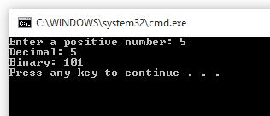

Screenshot 2 shows the same results as the second example in the Lab write up.

The Decimal value 26 is entered and displayed and the binary representation is correctly displayed as 11010.

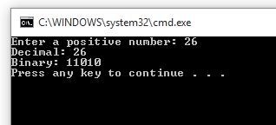

Screenshot 3 shows that the user will be prompted again until a positive number is entered and that 0 is returned for a 0 entry.

